**AWS PROJECT SUBMISSION**

**SCREENSHOTS NEEDED FOR DASHBOARDS:**

**AWS login screen with username**

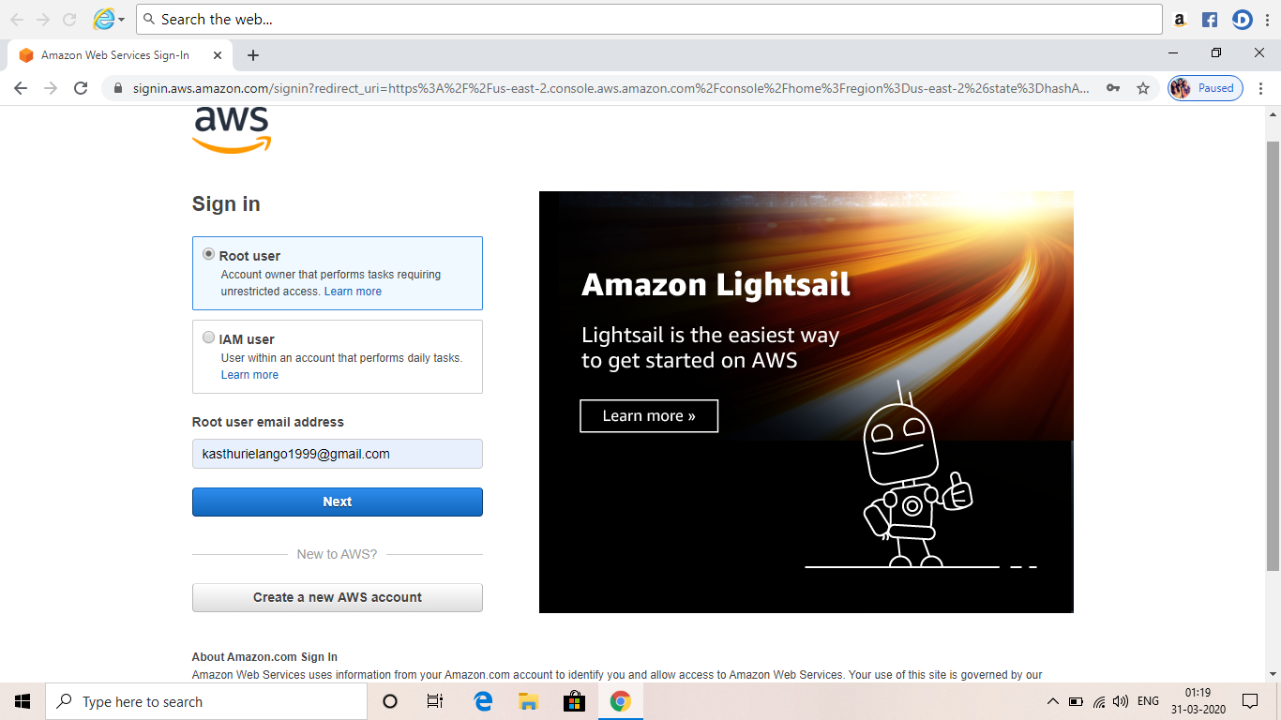

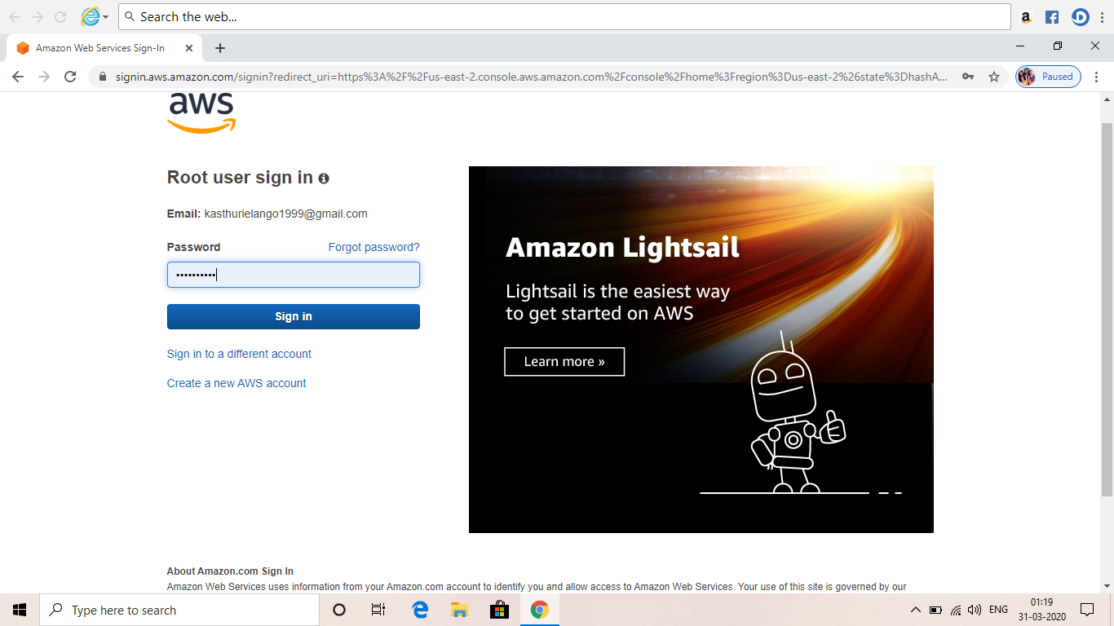

**EC2 Dashboard**

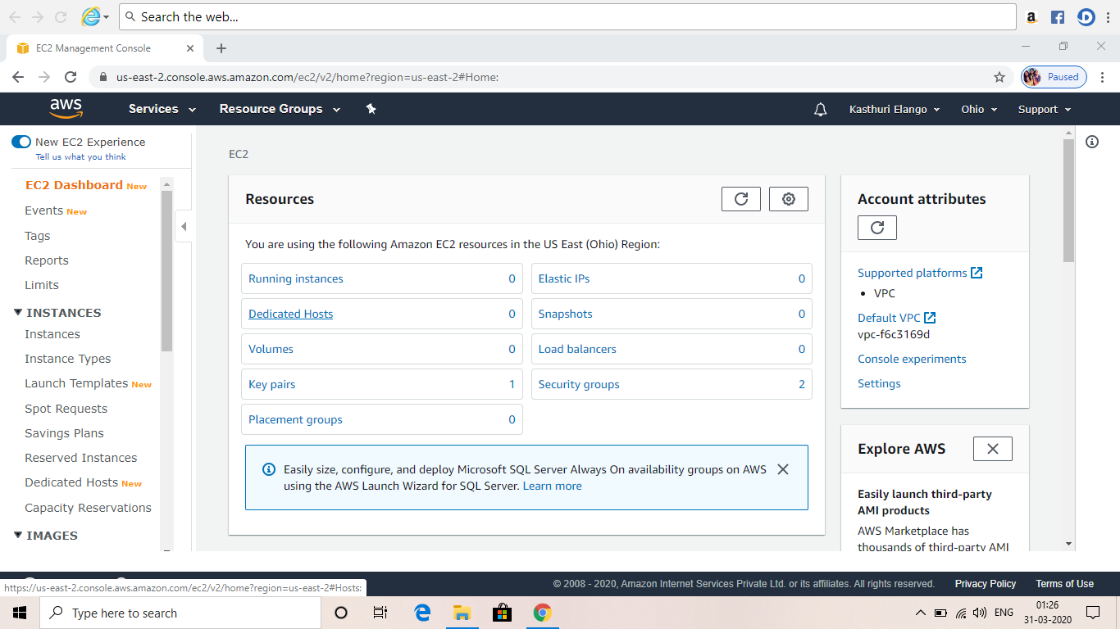

**S3 Dashboard**

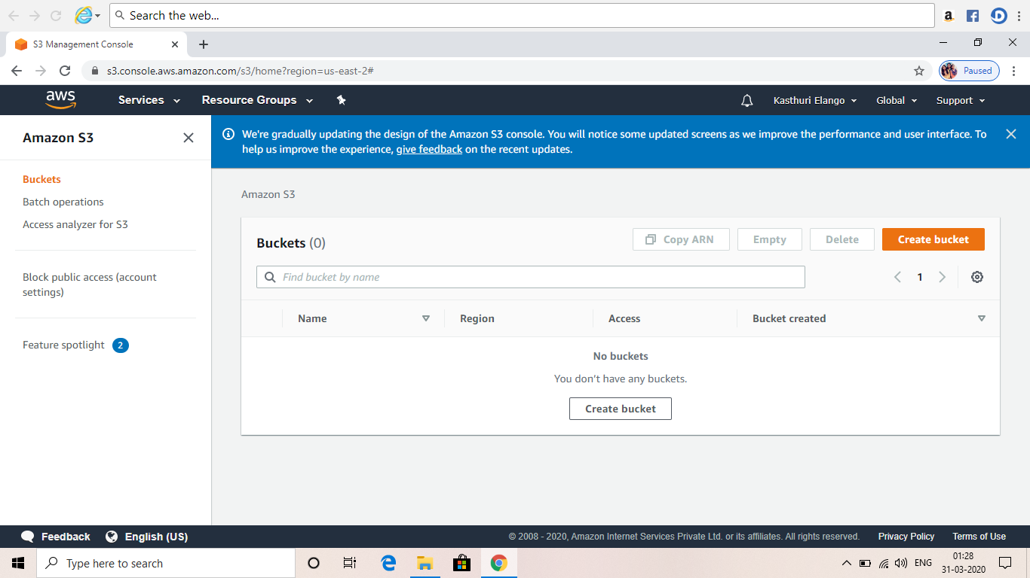

**Rekognition Dashboard**

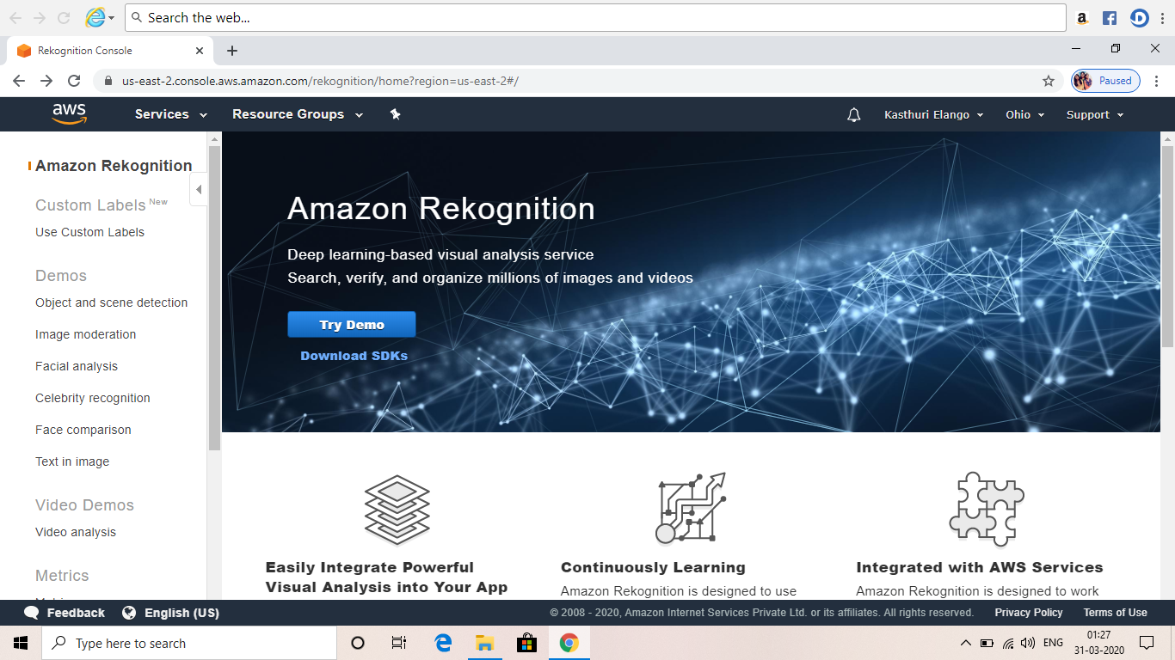

**SCREENSHOTS NEEDED FOR EC2**

**Choosing an AMI**

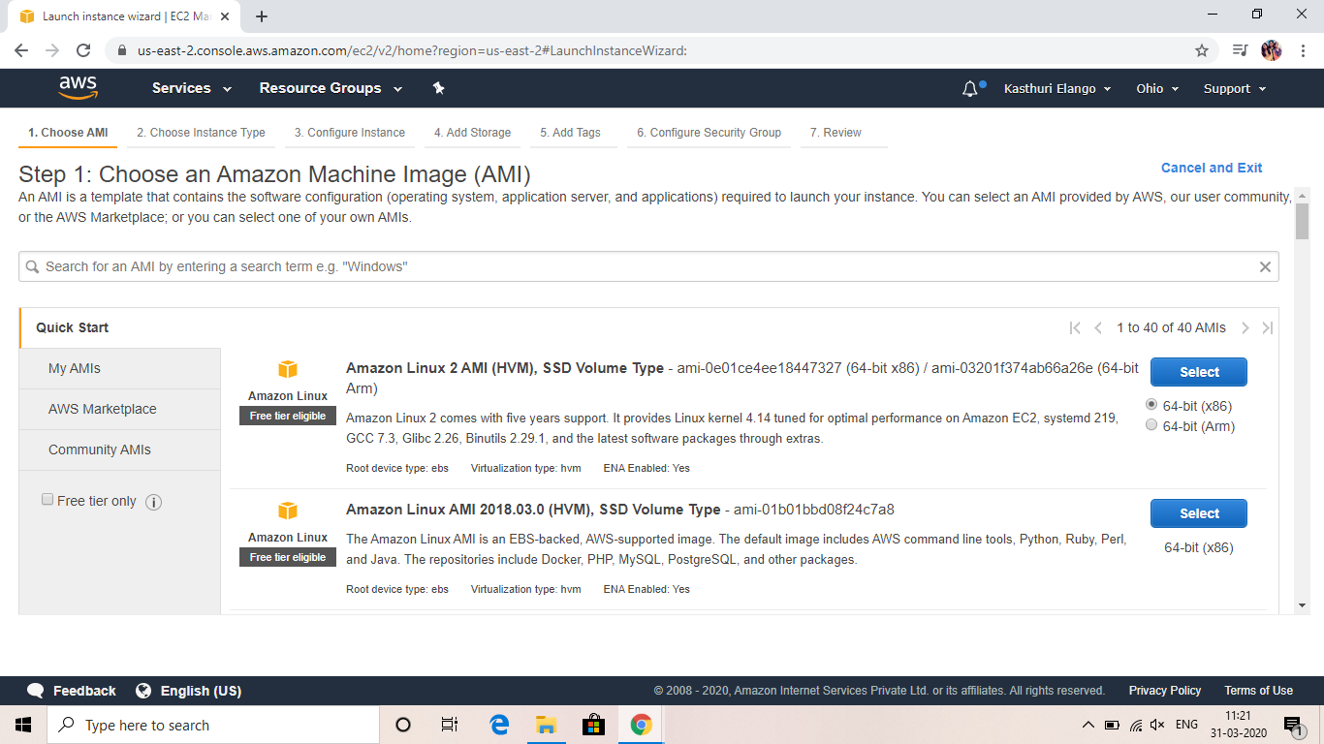

**Choosing an Instance type**

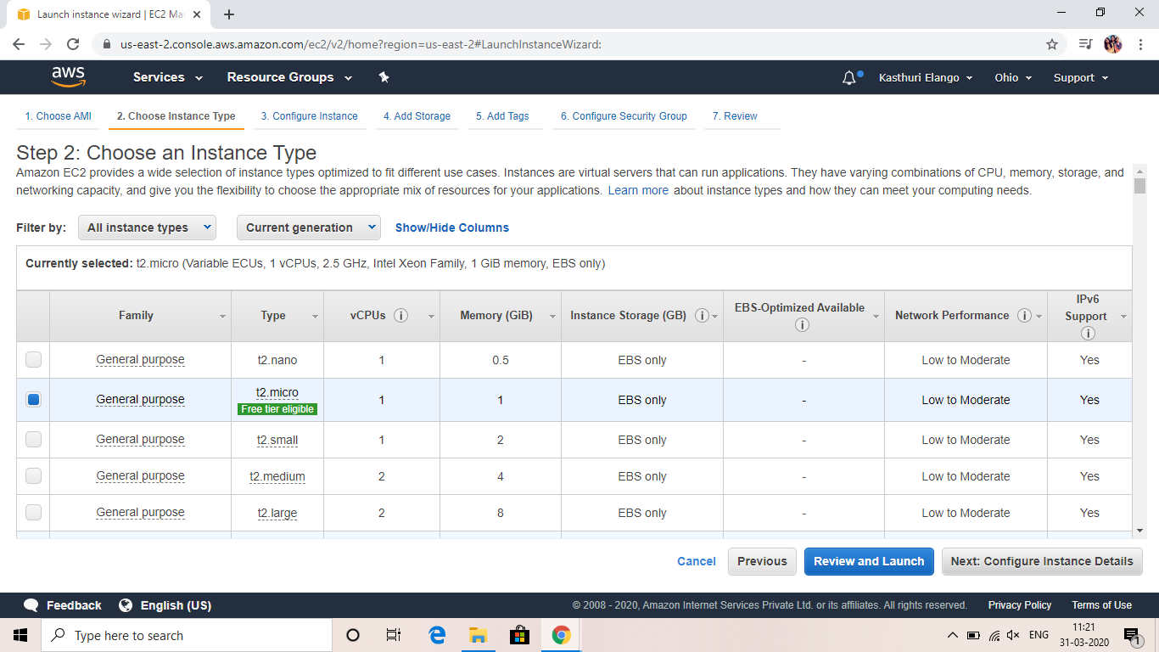

**Adding storage**

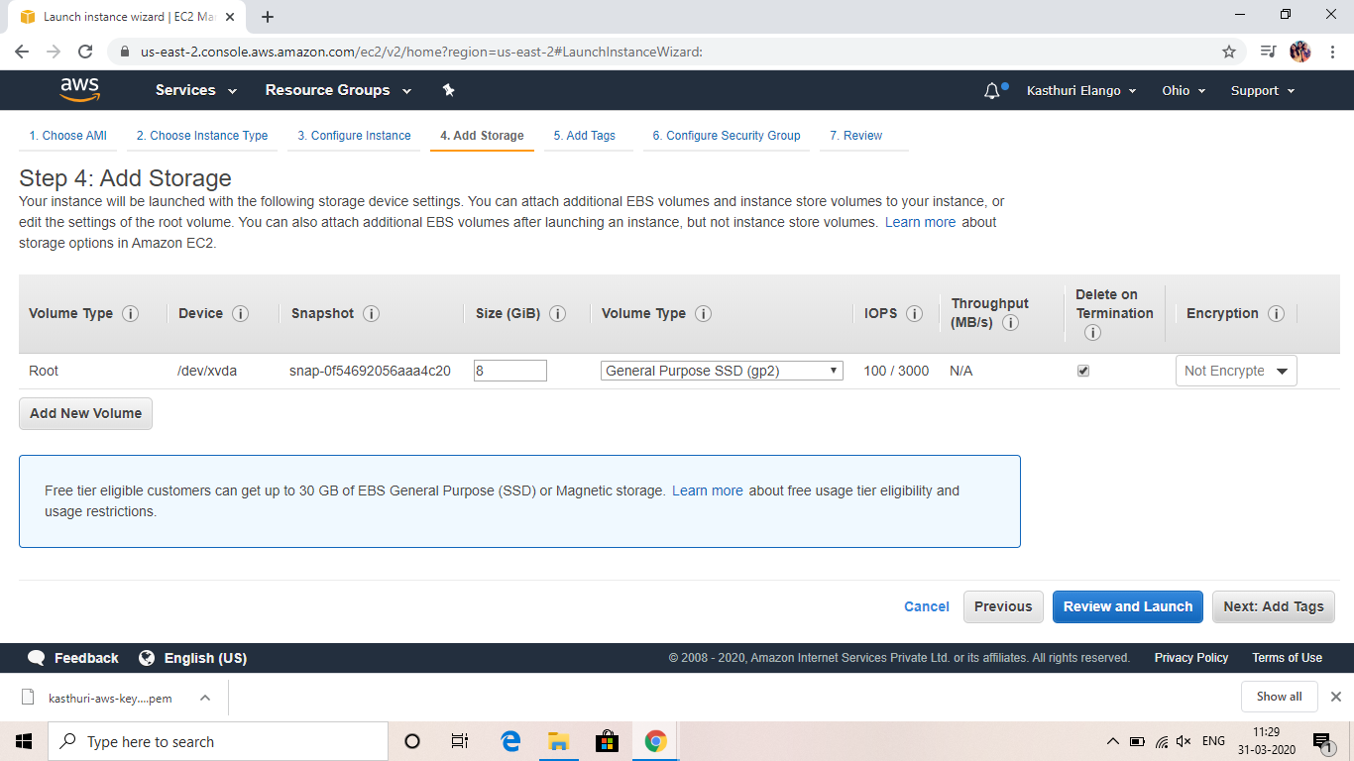

**Configuring Security Group**

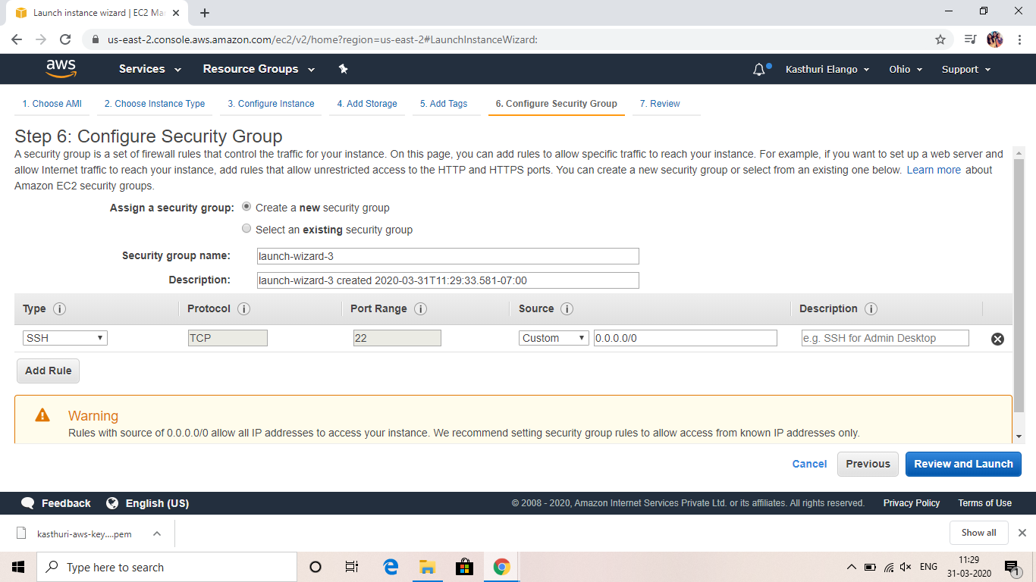

**Key Pair download**

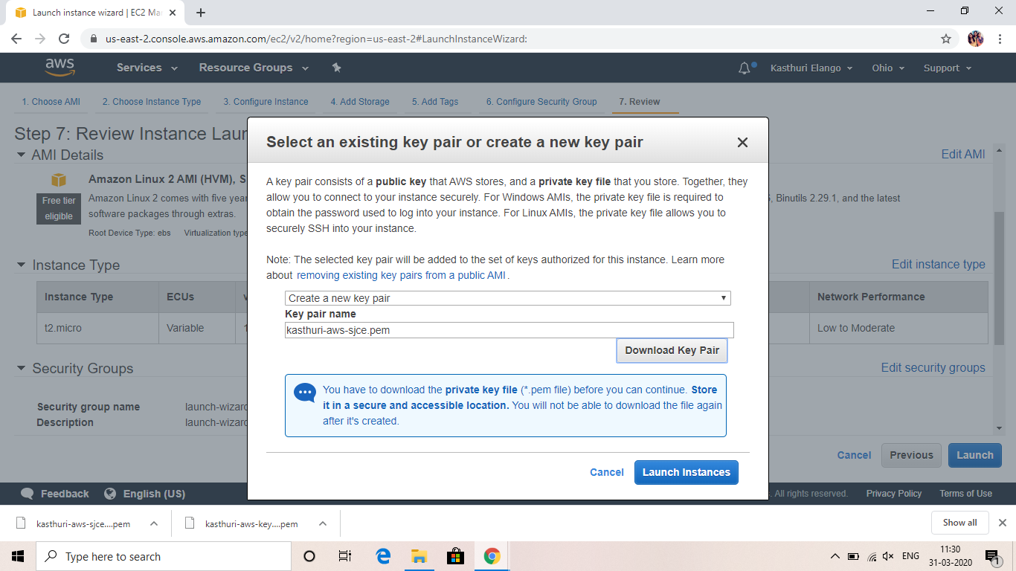

**PuTTYgen conversion from pem to ppk**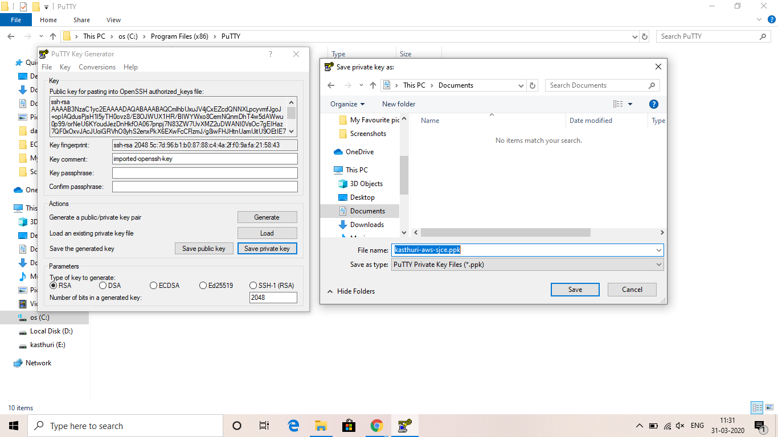

**Logged in EC2 black screen**

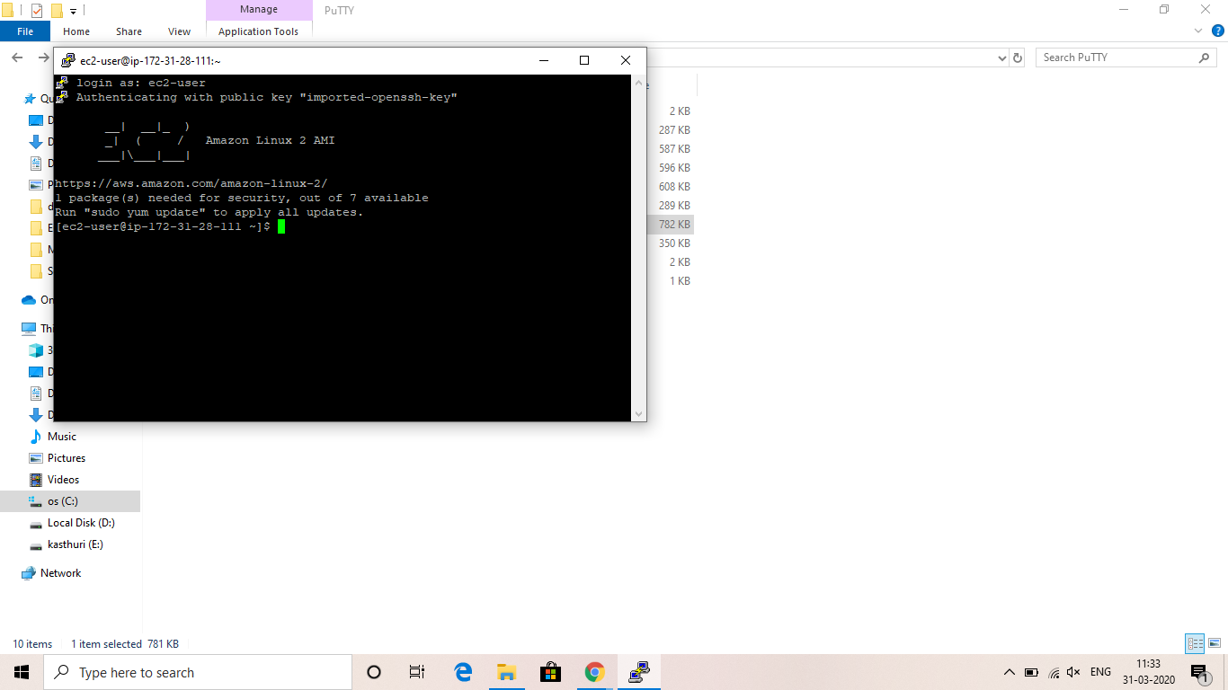

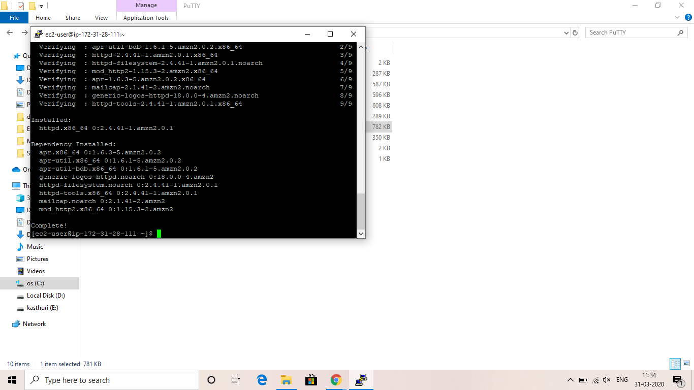

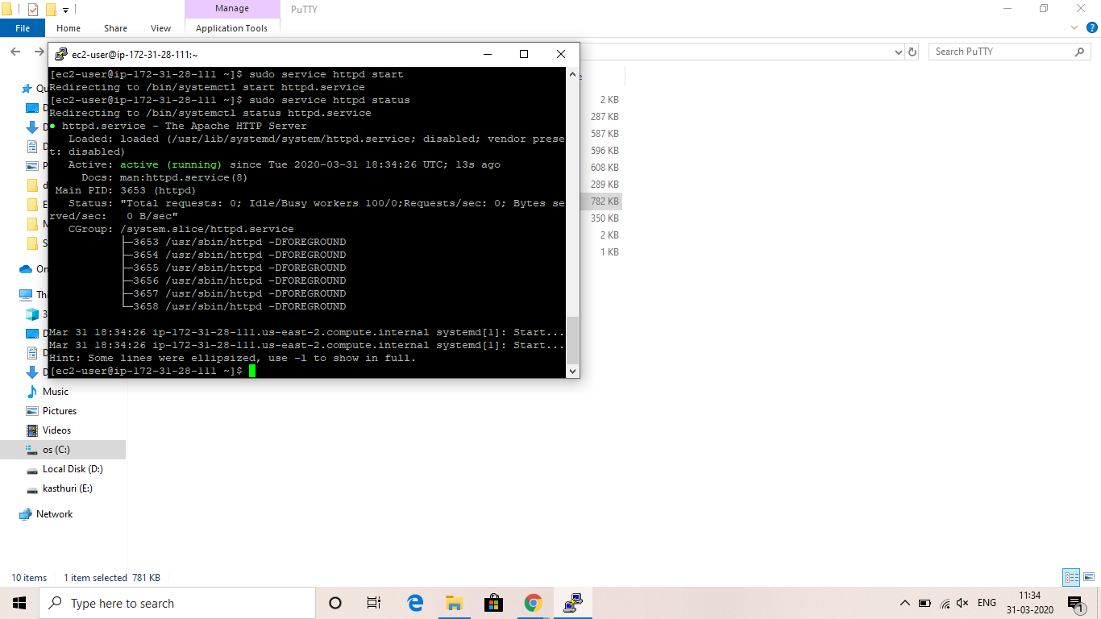

**Type the content in putty**

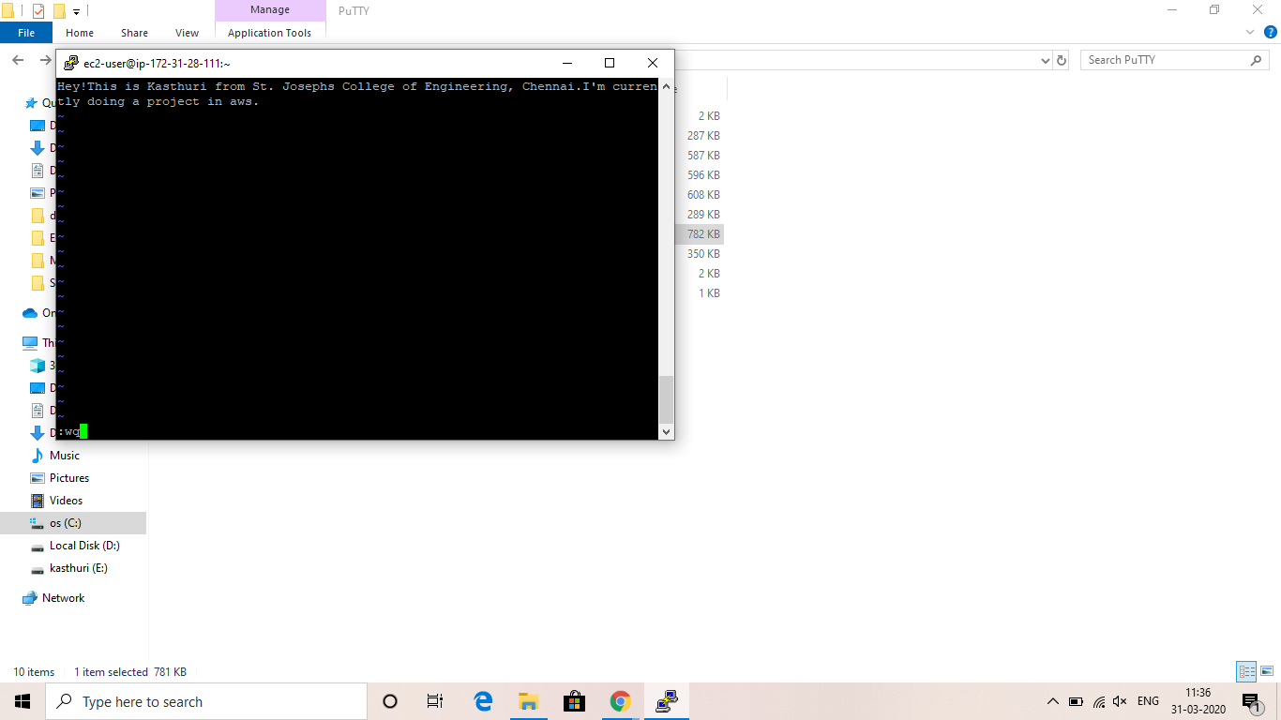

**The typed content is displayed in the browser**

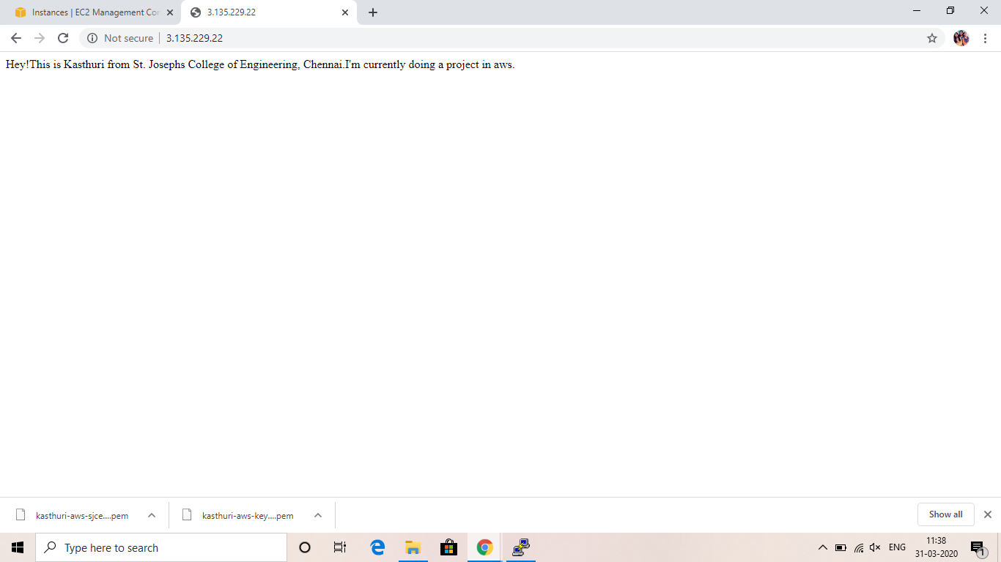

**SCREENSHOTS NEEDED FOR S3**

**Creating a bucket**

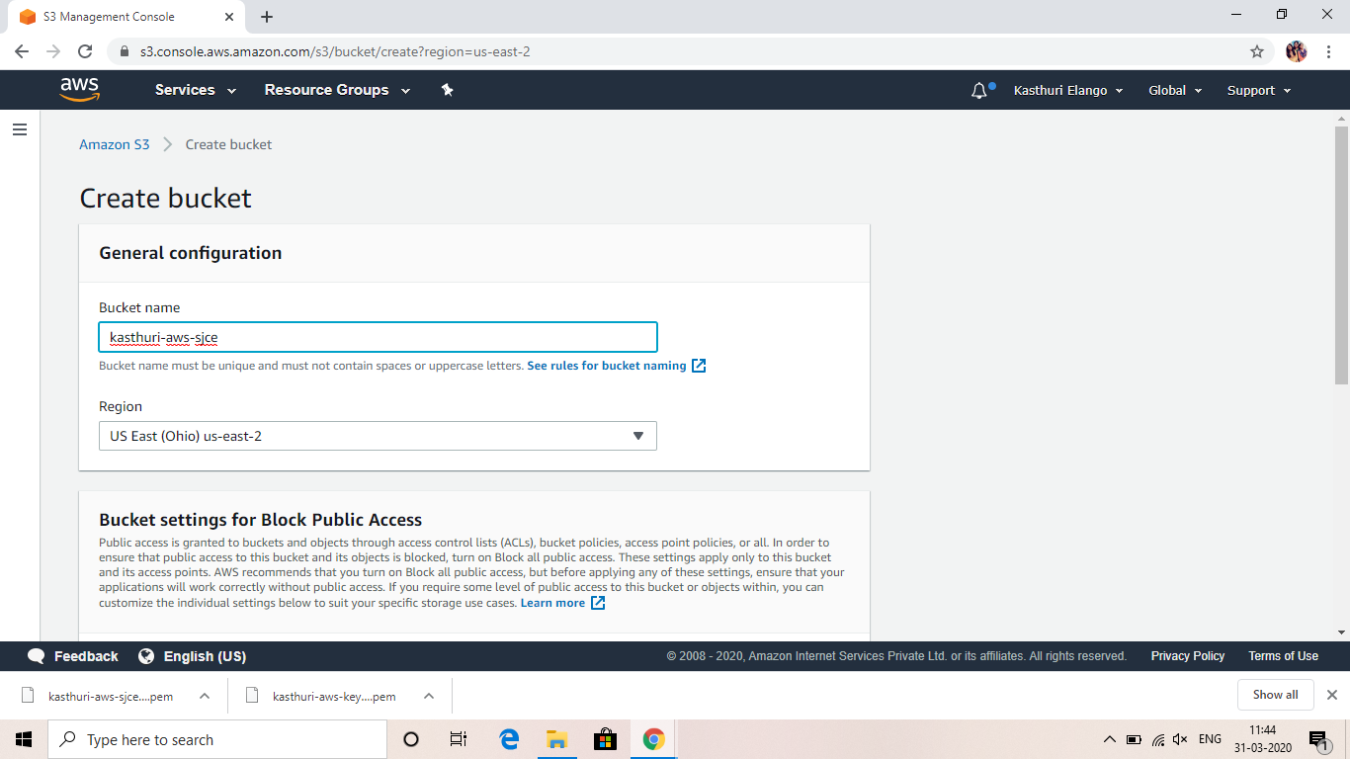

**Bucket is created**

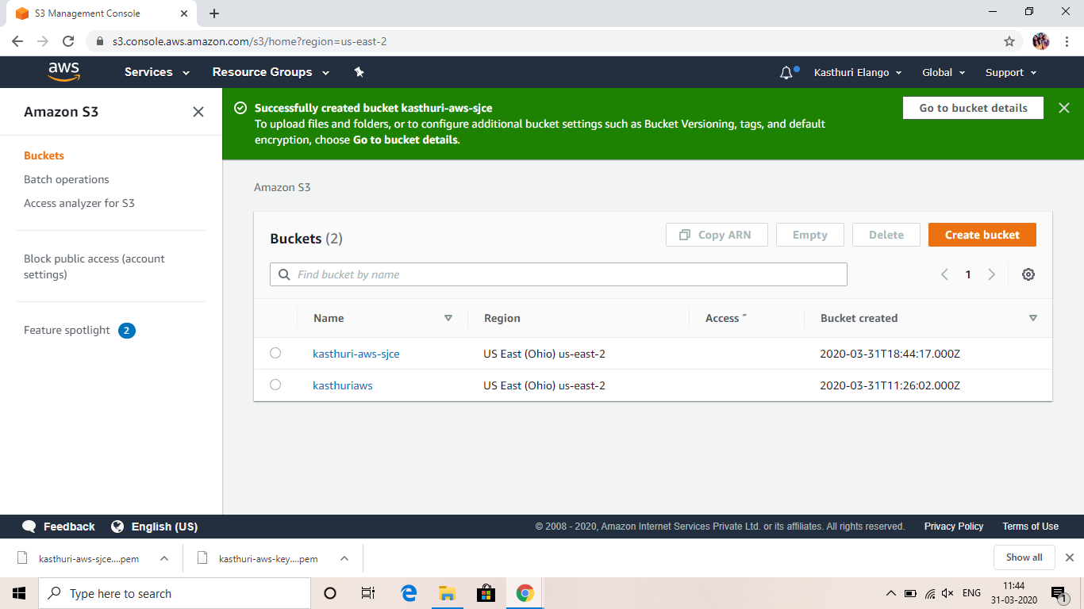

**Uploading an object**

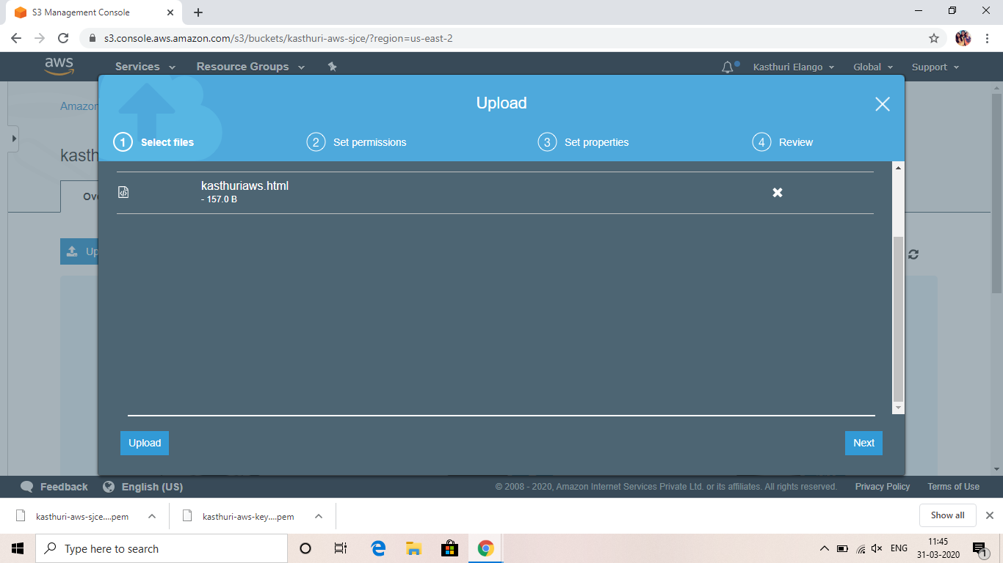

**Object is uploaded**

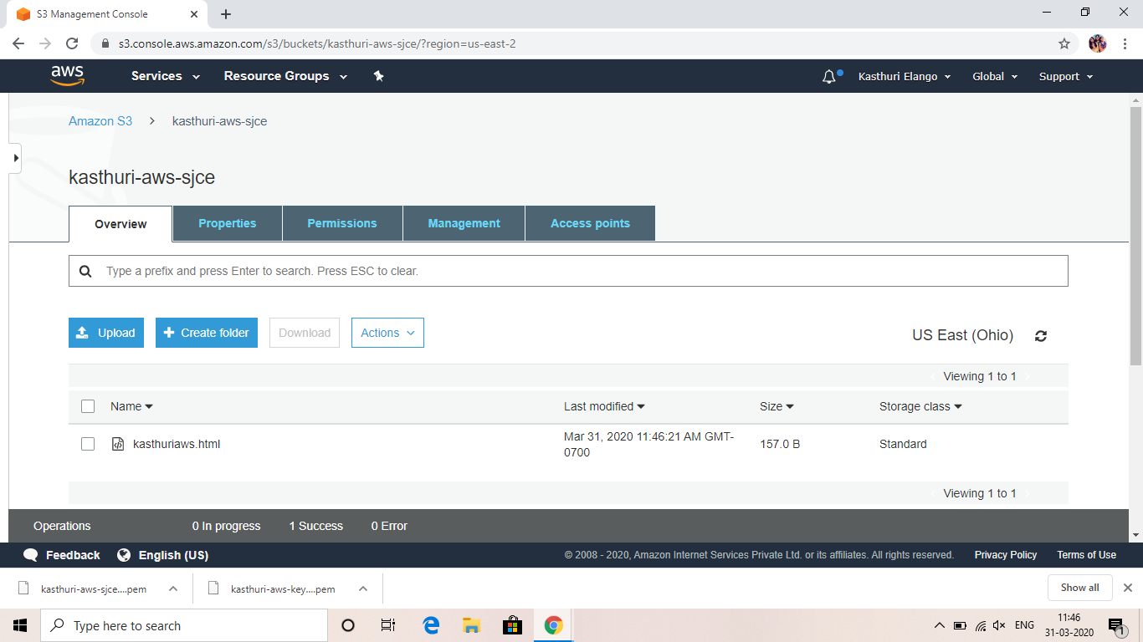

**Enabling static website**

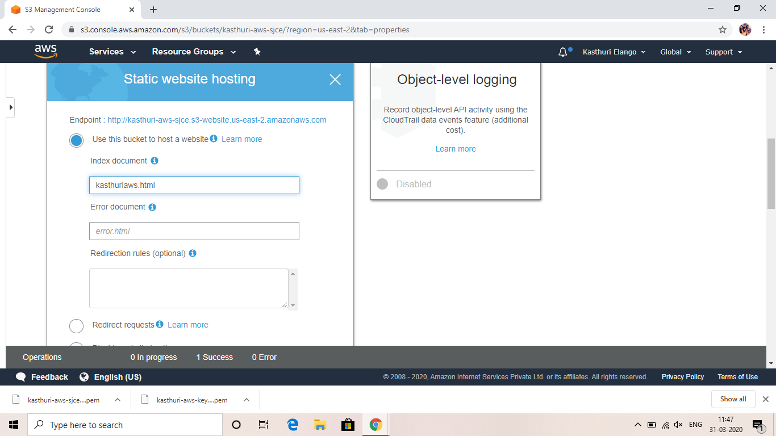

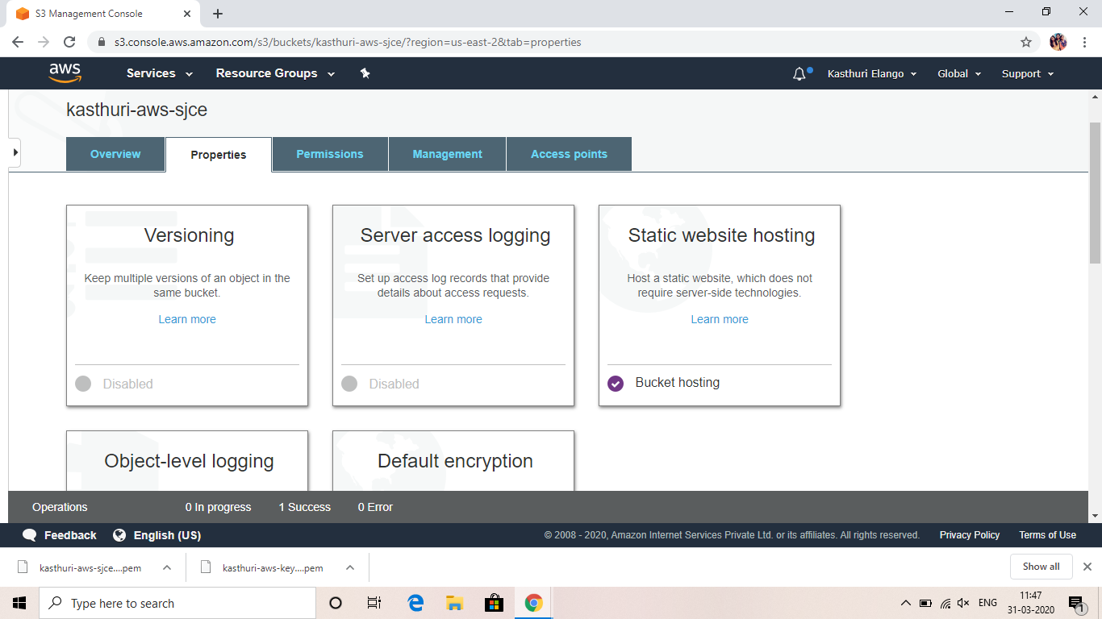

**Making the object public**

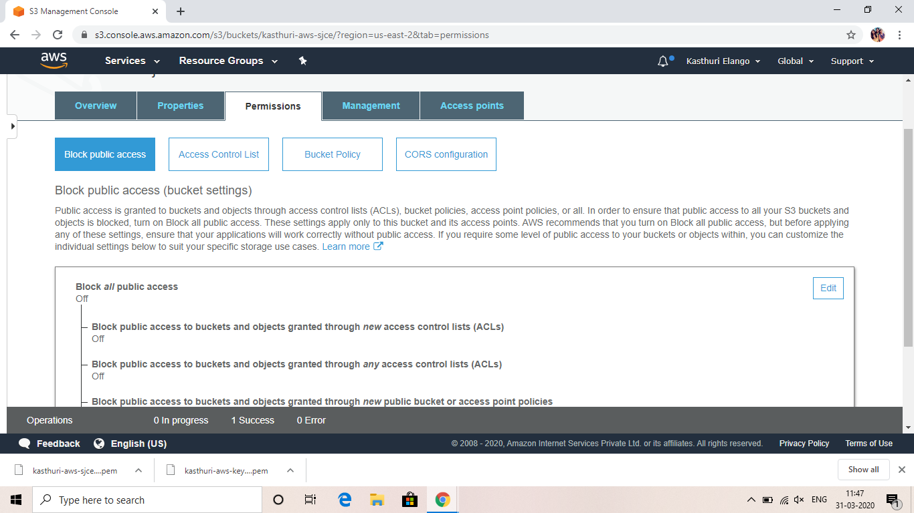

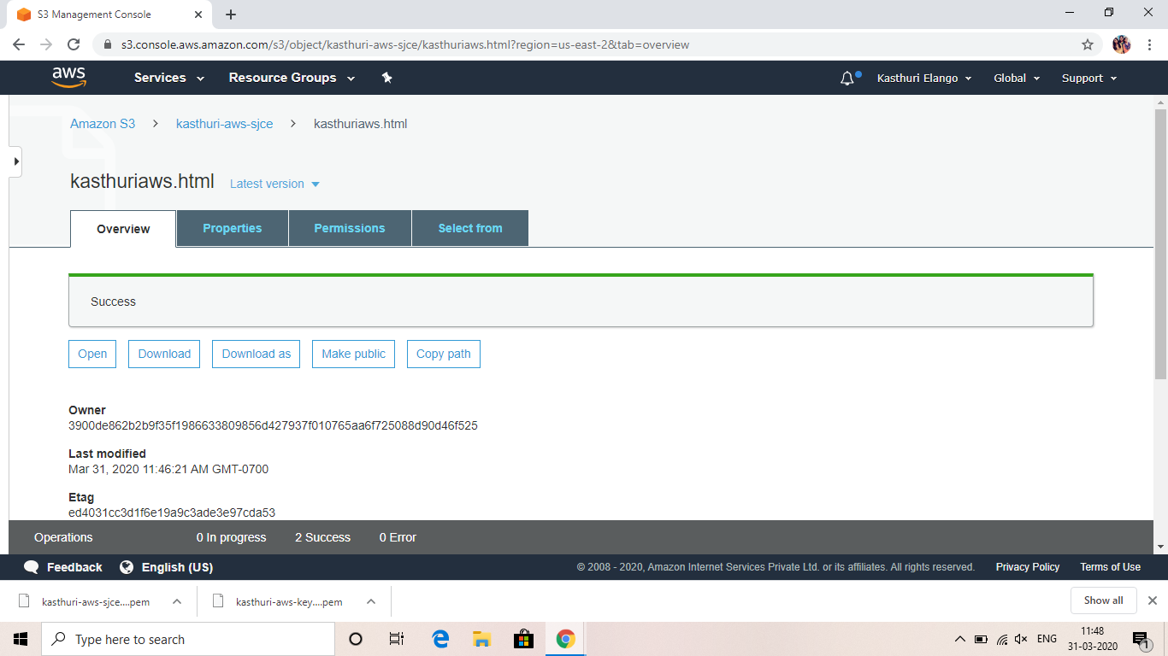

**Checking the S3 link on browser**

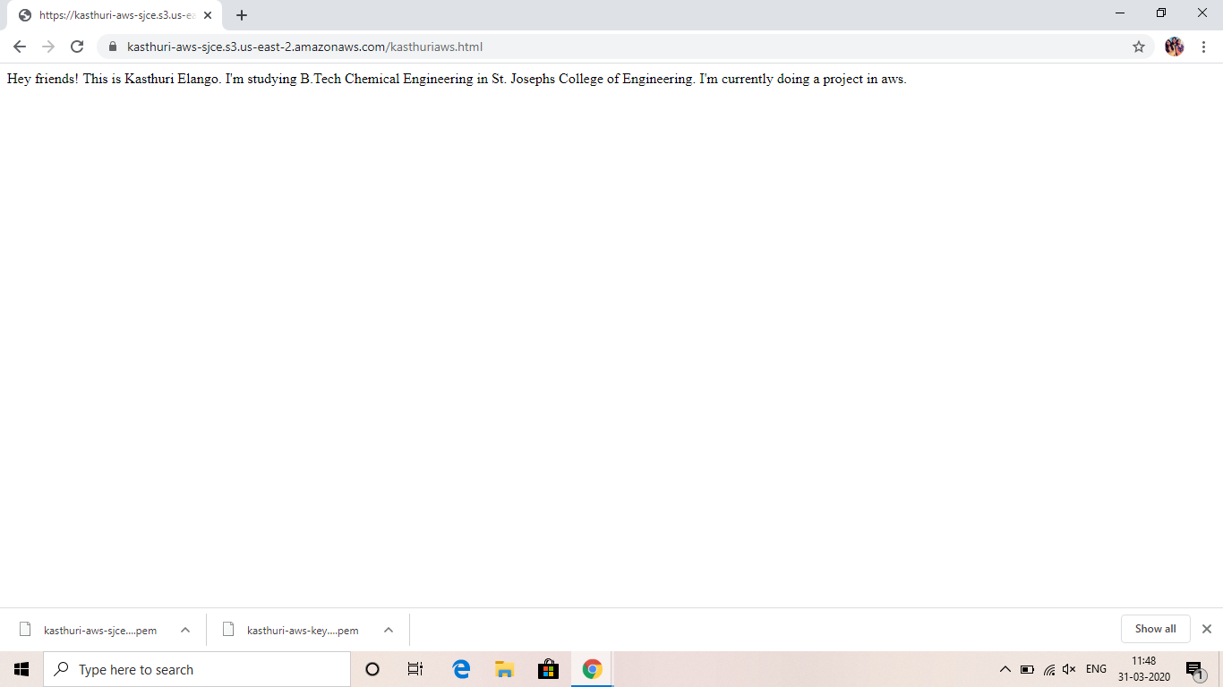

**SCREENSHOTS NEEDED FOR REKOGNITION**

**Face detect**

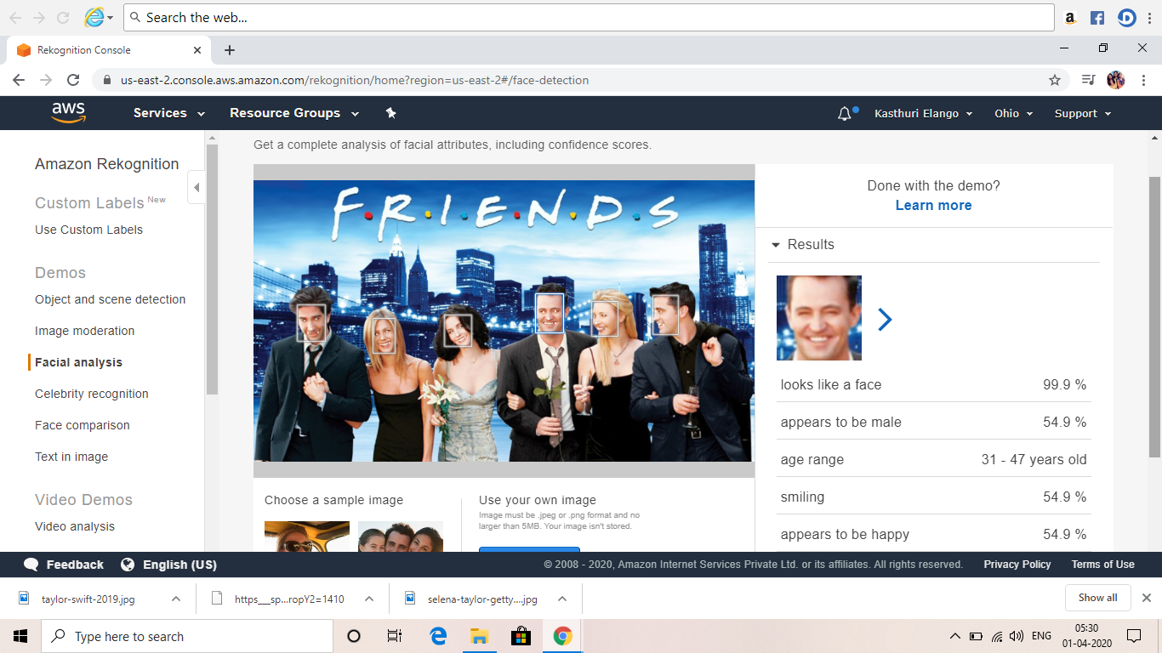

**Face compare**

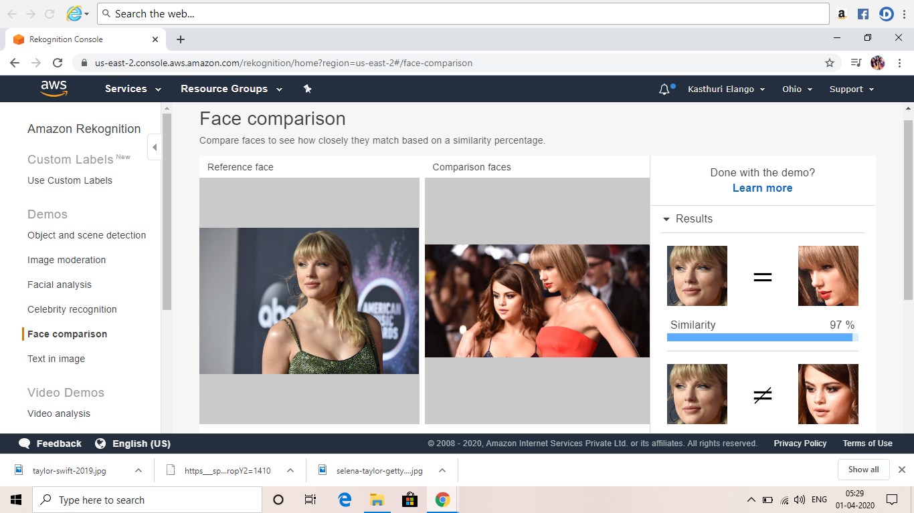

**Celebrity recognition**

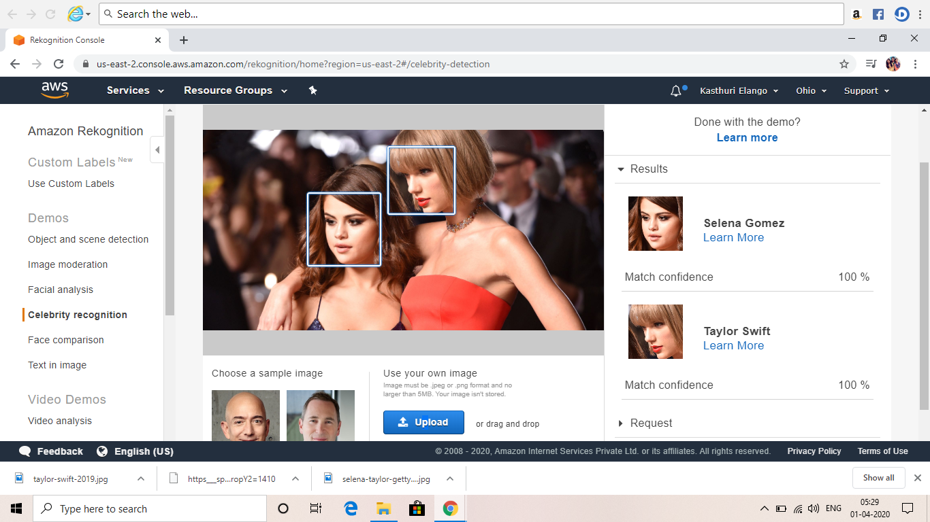

**Text in Image**

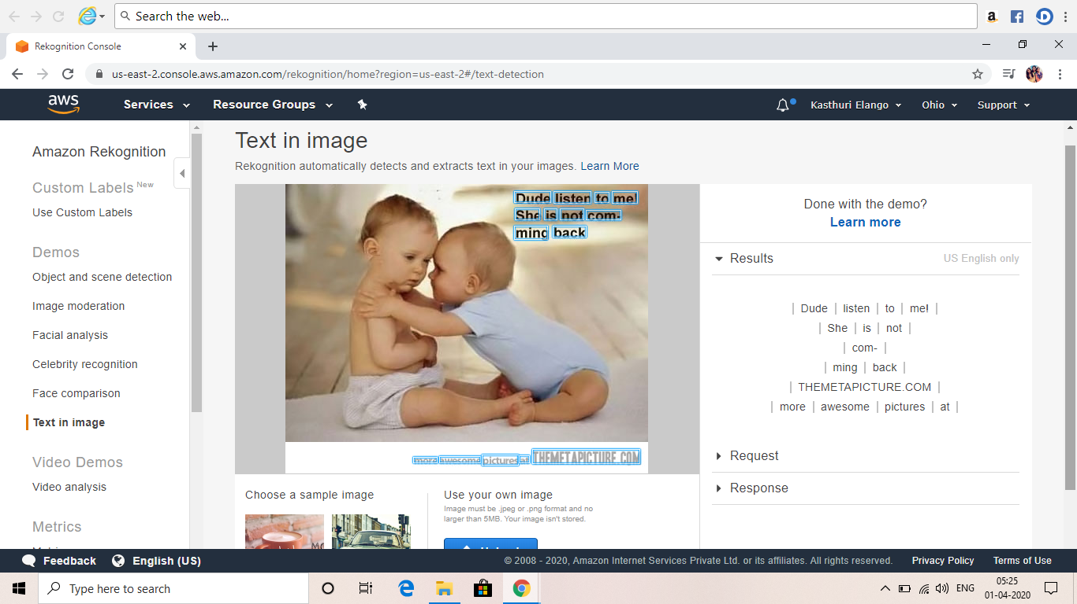

**SCREENSHOTS NEEDED FOR EC2 AND S3**

**Installing php**

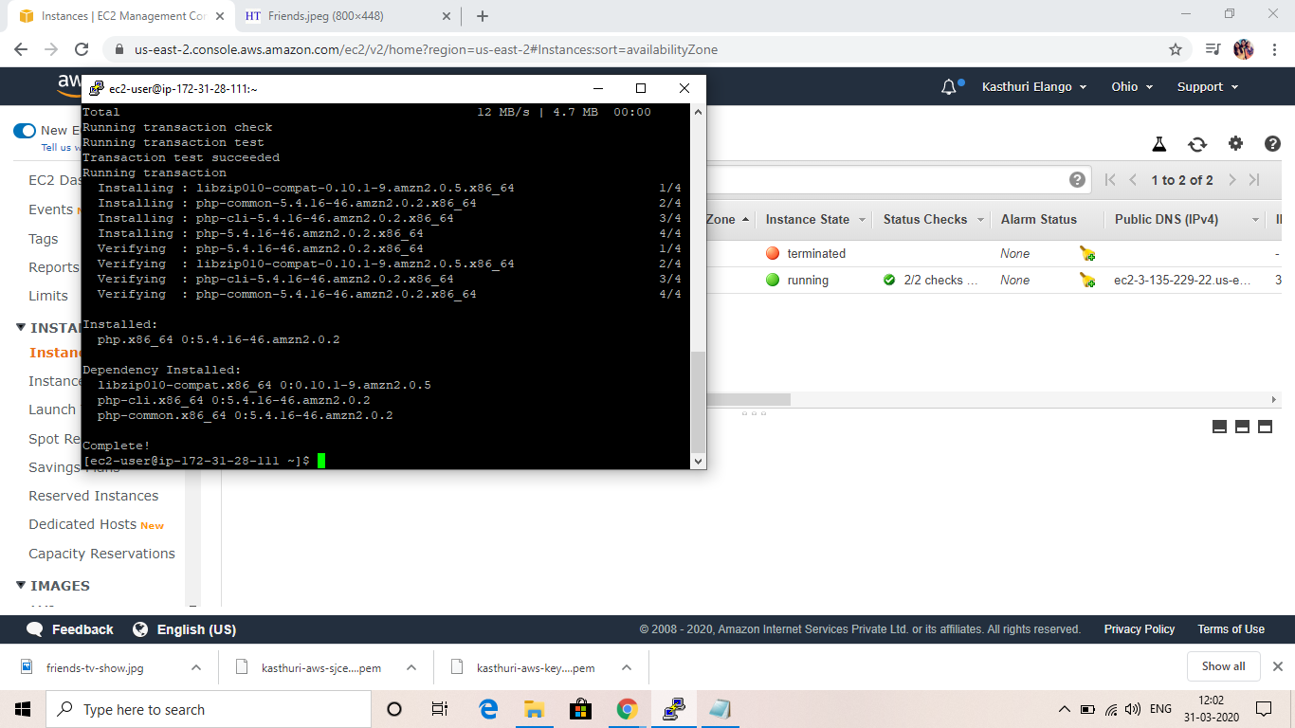

**Installing aws-sdk**

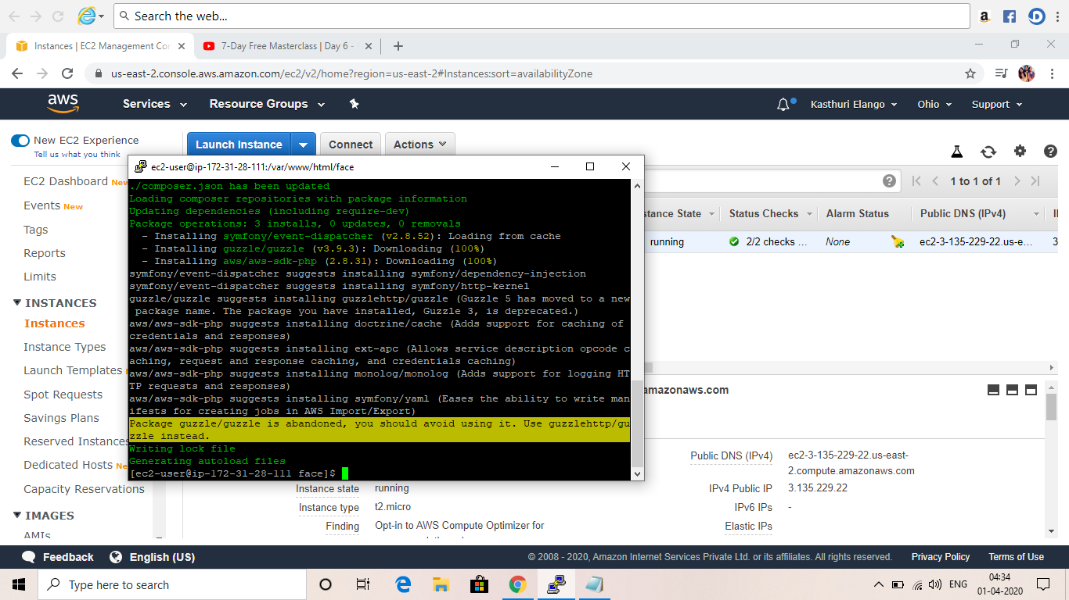

**Index.php is pasted and saved. Once this is done, the picture is uploaded**

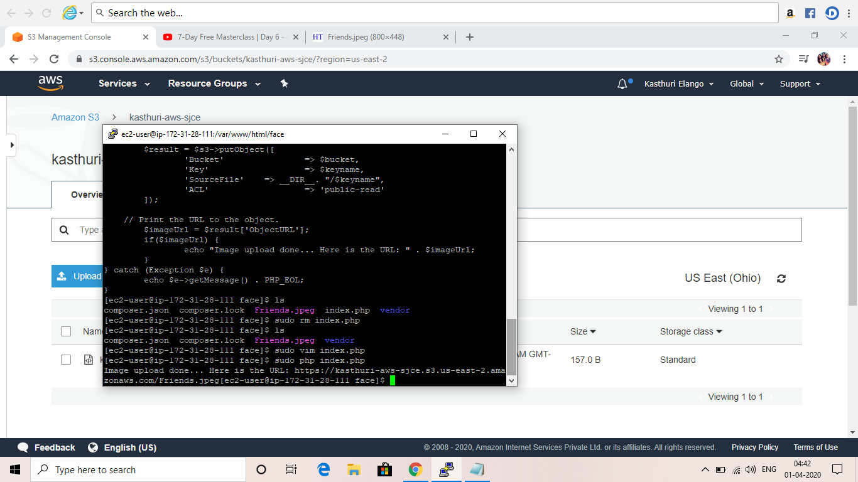

**After we refresh the page, we can clearly see the image has been uploaded successfully in the bucket.**

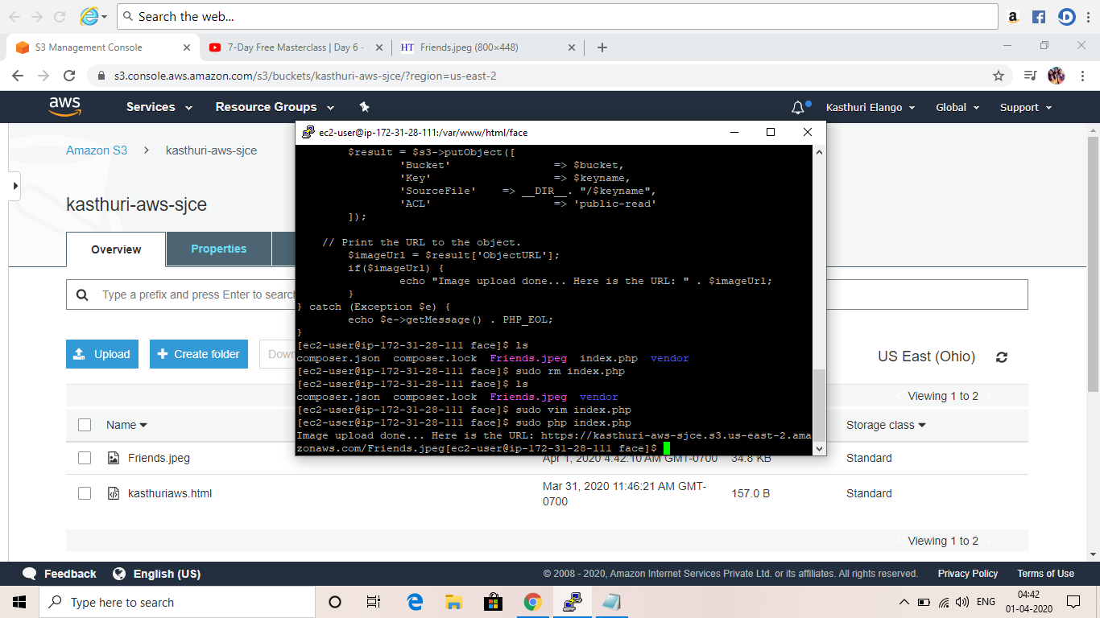

**When we check the link on browser, we can see the uploaded image**

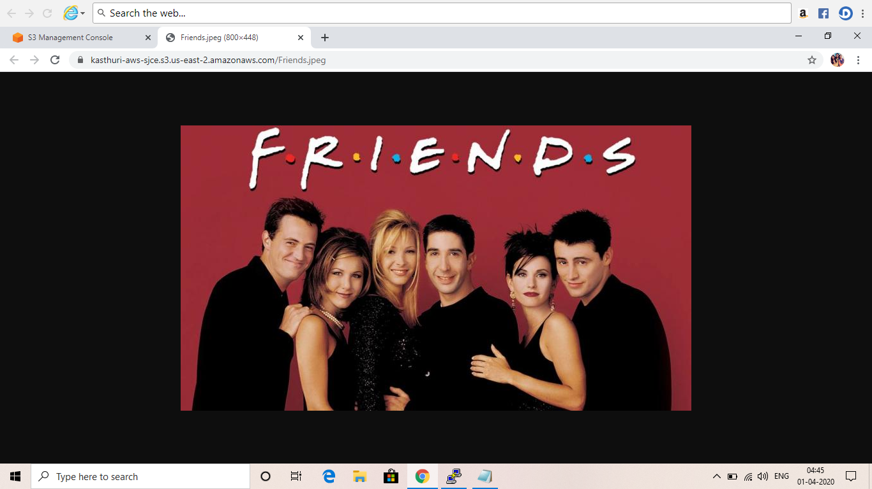

**SCREENSHOTS NEEDED FOR EC2 AND REKOGNITION**

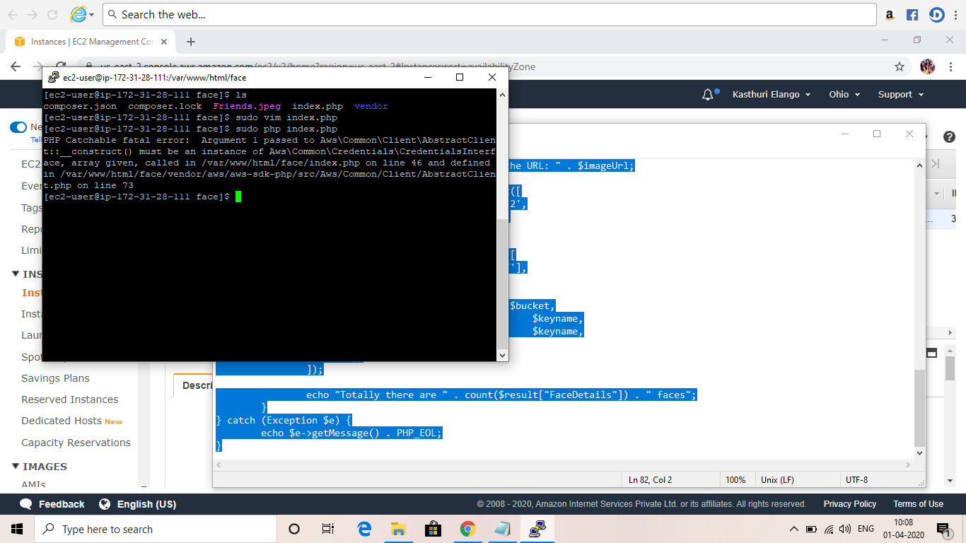

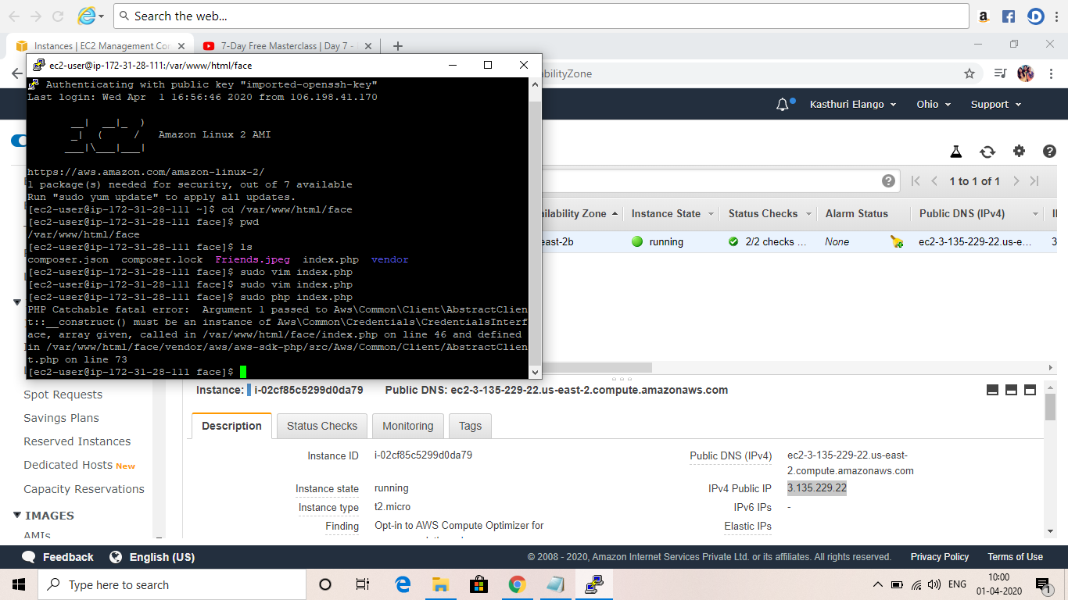

**My details:**

**NAME: Kasthuri El**

**DEGREE: B.Tech**

**COURSE: Chemical**

**COLLEGE NAME: St. Josephs College of Engineering**